Traffic Information
From Taoyuan Airport to Howard Civil Service International House
Add: 30, Xinsheng South Road, Sec. 3, Taipei Tel: 02-7712-2323

- Pick-up Service provided by the Howard Civil Service Intl. House
Simply fill out the pick-up service reservation form at the bottom of the Howard Reservation Form and fax it to the Howard.
Fare: Benz ( 1~3 persons, NT$1,470/per trip)
Mini-Van ( 3~7 persons, NT$1,890/per trip)

- By Bus and Metro
Where to buy bus tickets: Kuokuang LineTicket counter (located in the Arrival Passenger reception areas)
Terminal 1 Bus Platform: On the southwest side of the arrival passenger reception area
Terminal 2 Bus Platform: On the northeast side of the arrival passenger reception
Step1: Take Kuokuang Line No.1819 to Taiwan Railways Station
Fare: 145NTD / Interval: 15~20 min. / Driving Distance: 55 min.
Step2: Follow the direction to Metro Taipei Main Station
Take Green Line(Xindian Direction) to Taipower Building Station
Fare: 20NTD / Distance: 7 min.
Step3: Take the Exit 2, turn left and go straight along the Xinhai Road. (See Map)
Distance: 7 min.

- By Taxi
Terminal 1 queue: North side of the Arrival Hall
Terminal 2 queue: South side of the Arrival Hall
Fare: about 1200~1300 NTD / Driving Distance: about 45 min.

- By Bus and Taxi
Where to buy bus tickets: Toward You Air Bus Ticket counter (located in the Arrival Passenger reception areas)
Terminal 1 Bus Platform: On the southwest side of the arrival passenger reception area
Terminal 2 Bus Platform: On the northeast side of the arrival passenger reception
Step1: Tate Toward You Air Bus no.2060 to Howard Hotel
Fare: 145 NTD / Interval: 20~30 min. / Driving Distance: 60~70 min.
Step2: Take Taxi to Howard Civil Service International House
Fare: about 120 NTD / Driving Distance: about 10 min.

- By Taiwan High Speed Rail and Metro
Where to buy the shuttle bus tickets: U-BUS counter in Arrival Greeting Hall
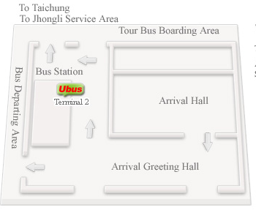
Terminal 1 Bus Platform: Terminal 2 Bus Platform:
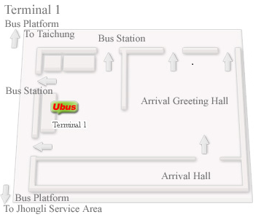

Step1: Take the shuttle bus to HSR Taoyuan Station
Fare: 30 NTD / Interval: 15~20 min. / Driving Distance: 15 min.
Step2: Take the HSR to Taipei Station
Fare: 160 NTD / Interval: 20~30 min. / Driving Distance: 20min.
Step3: Follow the direction to Metro Taipei Main Station
Take Green Line(Xindian Direction) to Taipower Building Station
Fare: 20NTD / Distance: 7 min.
Step4: Take the Exit 2, turn left and go straight along the Xinhai Road. (See Map)
Distance: 7 min.

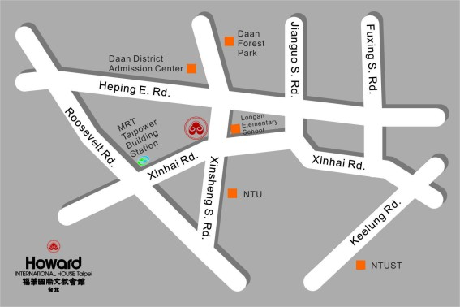
Traffic Information
From Taipei SongShan Airport to Howard Civil Service International House
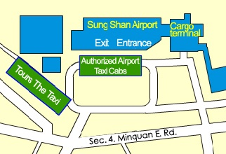
- By Taxi
Platform：See Map
Fare: about 200 NTD
Driving Distance: about 18 min.

- By Metro
Step1: Follow the direction to Metro SongShan Airport Station
Step2: Take the Brown Line(Taipei Zoo Direction) to Zhongxiao Fuxing Station
Step3: Transfer to the Blue Line(Yongning Direction) to Taipei Main Station
Step4: Transfer again to Green Line(Xindian Direction) to Taipower Building
Station
Fare: 30 NTD / Distance: 18 min.
Step5: Take the Exit 2, turn left and go straight along the Xinhai Road. (See Map)
Distance: 7 min.

